Group 10

Dart Programming Lab 1 outputs

Part 1 : Functions

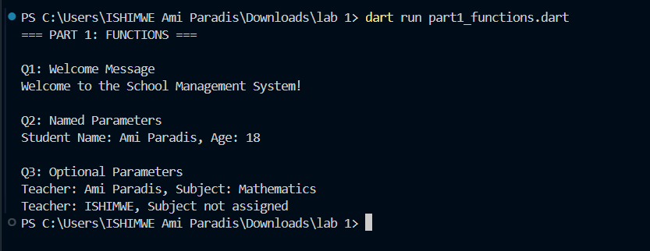

Part 2 : Constructors and Class
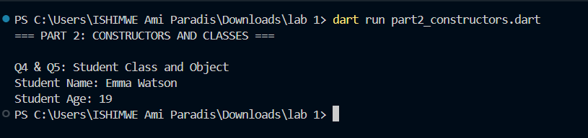

PART 3 : Inheritance

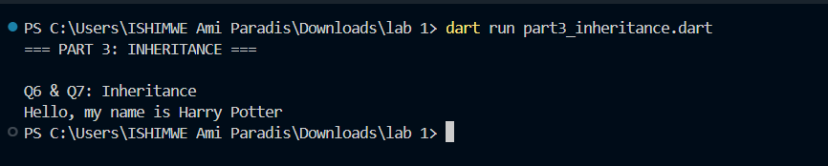

Part 4: Interfaces

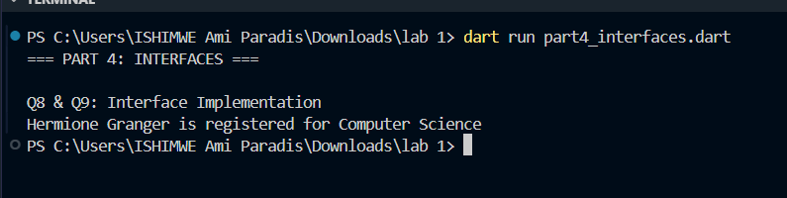

Part 5 :Mixins

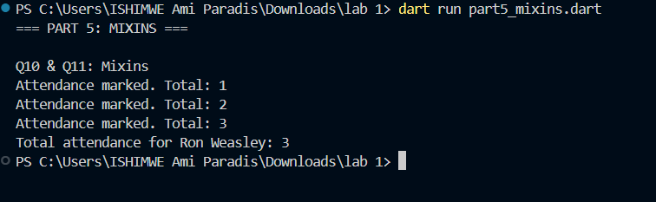

Part 6: Collections

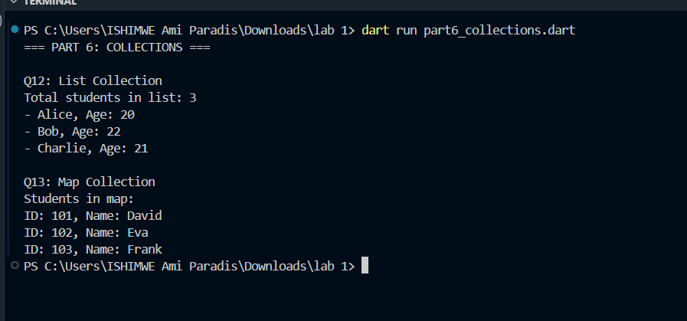

Part 7:Anonymous and Arrow function

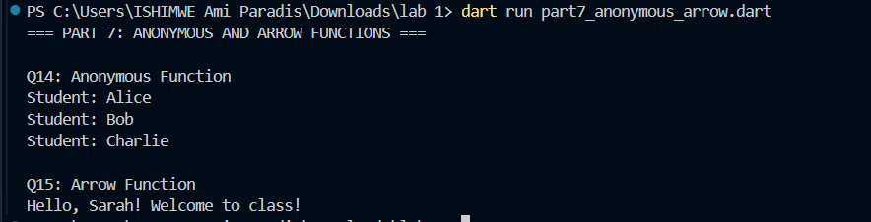

Part 8:Asynchronous Programming

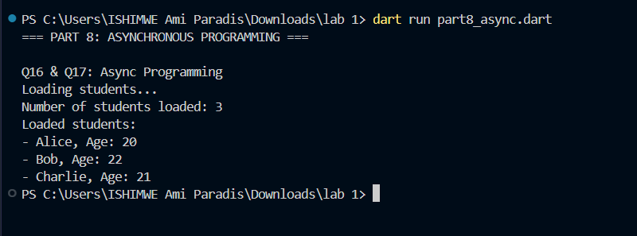

Part 9 :Integrations

